**Angelica Semenec**

**012179180**

**Lab 5**

**Power Consumption and EnergyTrace on MSP432 MCU**

**Purpose**

The purpose of this lab is to become familiarized with the power consumption of the MCU using the tool EnergyTrace, which measures and displays the application’s energy profile.

**Exercise 1**

***Exercise 1.1 Software Method***

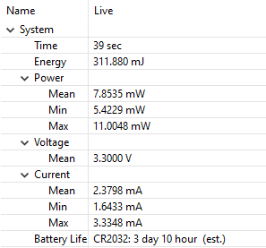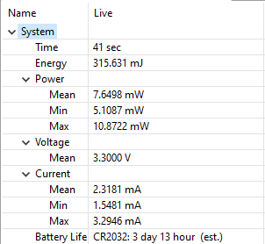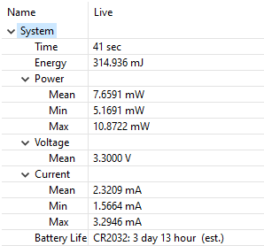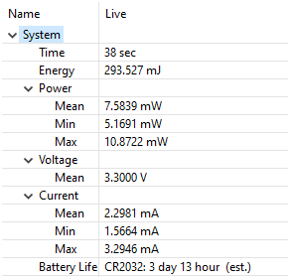

|  |  |  |
| --- | --- | --- |
| ***Measurement*** | ***Energy (mJ)*** | ***Mean Current (mA)*** |
| **1** | 311.880 | 2.3798 |
| **2** | 315.631 | 2.3181 |
| **3** | 314.936 | 2.3209 |
| **4** | 293.527 | 2.2981 |
| **Average** | 308.994 | 2.3292 |

***Exercise 1.2 Hardware Method***

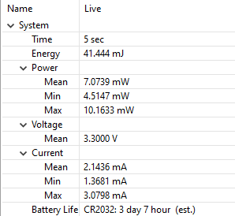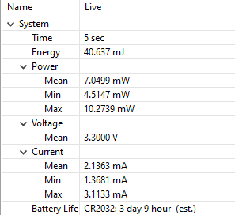

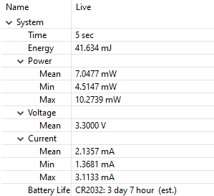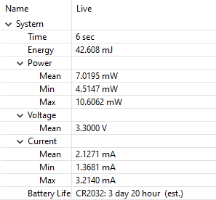

|  |  |  |
| --- | --- | --- |
| ***Measurement*** | ***Energy (mJ)*** | ***Mean Current (mA)*** |
| **1** | 41.444 | 2.1436 |
| **2** | 40.637 | 2.1363 |
| **3** | 41.634 | 2.1357 |
| **4** | 42.608 | 2.1271 |
| **Average** | 41.581 | 2.1357 |

***Exercise 1.3 DMA Method***

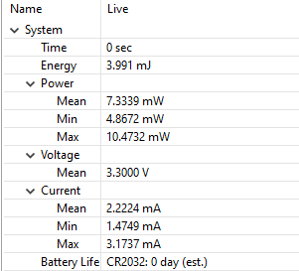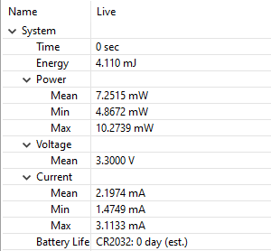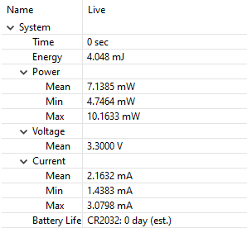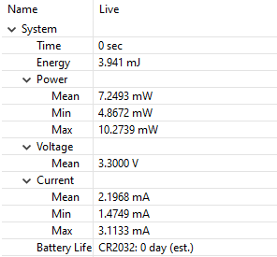

|  |  |  |
| --- | --- | --- |
| ***Measurement*** | ***Energy (mJ)*** | ***Mean Current (mA)*** |
| **1** | 3.991 | 2.2224 |
| **2** | 4.110 | 2.1974 |
| **3** | 4.048 | 2.1632 |
| **4** | 3.941 | 2.1968 |
| **Average** | 4.023 | 2.1950 |

***Exercise 1.4 DMA Low-Power Mode Method***

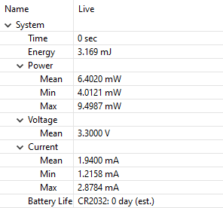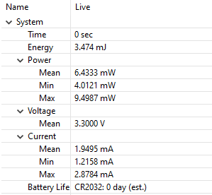

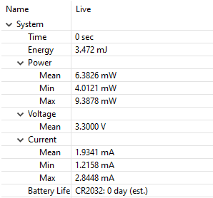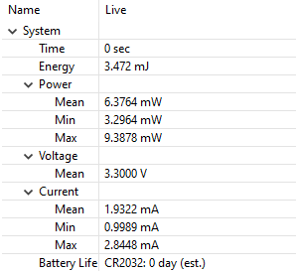

|  |  |  |
| --- | --- | --- |
| ***Measurement*** | ***Energy (mJ)*** | ***Mean Current (mA)*** |
| **1** | 3.169 | 1.9400 |
| **2** | 3.474 | 1.9495 |
| **3** | 3.472 | 1.9341 |
| **4** | 3.472 | 1.9322 |
| **Average** | 3.397 | 1.9390 |

***Exercise 1.5***

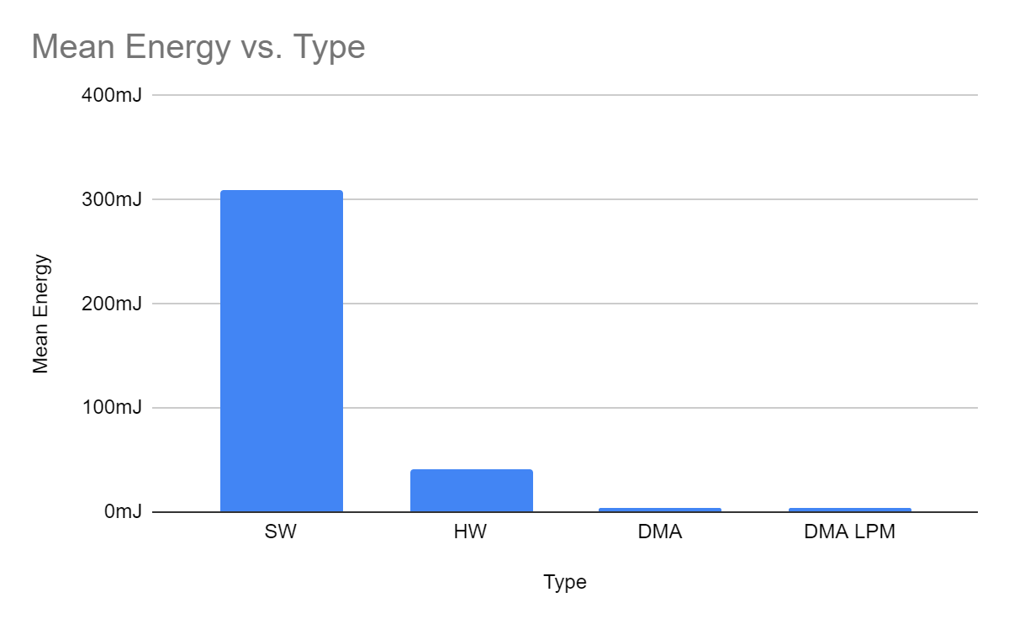

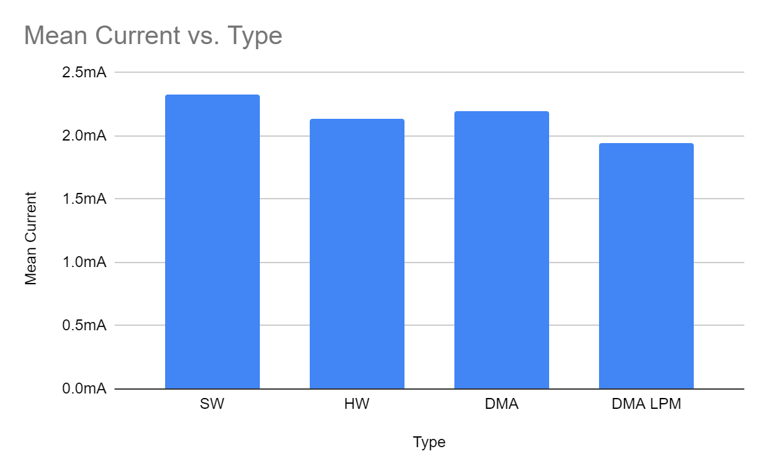

|  |  |  |
| --- | --- | --- |
| ***Method*** | ***Mean Energy (mJ)*** | ***Mean Current (mA)*** |
| **Software** | 308.994 | 2.3292 |
| **Hardware** | 41.581 | 2.1357 |
| **DMA** | 4.023 | 2.1950 |
| **DMA Low-Power Mode** | 3.397 | 1.9390 |

Comparing the different methods through their overall energy consumption reveals some dramatic differences, however the differences between the methods concerning their current is much more subtle.

The software calculation used significantly more energy to do the computation when compared with any other method. This method also used the highest mean current. The hardware method used significantly less energy than the software method, but was still significantly higher than either of the DMA methods. There is only a small difference between the DMA method in active mode and the DMA method in low-power mode (DMA LPM) when comparing average energy. The DMA LPM consumed the least amount of energy as well as the smallest mean current.

The software method of calculation is energy-intensive and had the highest mean current when compared to the other methods tested. Each instruction is carried out through software, which involves many memory accesses. The hardware method uses less energy than the software method because much of the computation is done through hardware designed to accelerate the computation. This significantly reduces the number of memory accesses, thus reducing the overall power consumption. The DMA method allows for the most energy-efficient transfer from memory as it leaves the CPU available for computation and reduces the energy needed to make memory transfers. The DMA method in low-power mode further reduces the average energy and current because program execution is suspended during the DMA transfer, which means that the processor is not consuming as much energy.

**Appendix**

|  |
| --- |
| **main.c** |
| #include <ti/devices/msp432p4xx/driverlib/driverlib.h>  #include <stdio.h>  #include <stdlib.h>  #define CRC32_POLY 0xEDB88320  #define CRC32_INIT 0xFFFFFFFF  /* DMA Control Table */  #if defined(__TI_COMPILER_VERSION__)  #pragma DATA_ALIGN(controlTable, 1024)  #elif defined(__IAR_SYSTEMS_ICC__)  #pragma data_alignment=1024  #elif defined(__GNUC__)  __attribute__ ((aligned (1024)))  #elif defined(__CC_ARM)  __align(1024)  #endif  uint8_t controlTable[1024];  #define DATA_SIZE 1024 // Cannot be greater than 1024 for DMA method  uint8_t myData[DATA_SIZE];  static uint32_t calculateCRC32(uint8_t* data, uint32_t length);  volatile uint32_t hwCalculatedCRC, swCalculatedCRC, dmaCalculatedCRC;  #define LOOP_COUNT 500 // Number of iterations to do  //#define DO_PRINTF  #define USE_SW_METHOD  #define USE_HW_METHOD  #define USE_DMA_METHOD  #define USE_DMA_LPM_METHOD  int dma_channel_number = 0;  volatile bool dma_done;  int main(void)  {  int loop;  /* Stop WDT */  MAP_WDT_A_holdTimer();  #ifdef DO_PRINTF  printf("Lab 5. Exercise 1.\n");  #endif  #if defined(USE_DMA_METHOD) || defined(USE_DMA_LPM_METHOD)  /* Configuring DMA module */  MAP_DMA_enableModule();  MAP_DMA_setControlBase(controlTable);  MAP_DMA_setChannelControl(UDMA_PRI_SELECT, UDMA_SIZE_8 | UDMA_SRC_INC_8 | UDMA_DST_INC_NONE | UDMA_ARB_1024);  /* Assigning/Enabling Interrupts */  MAP_DMA_assignInterrupt(DMA_INT1, 0);  MAP_Interrupt_enableInterrupt(INT_DMA_INT1);  MAP_Interrupt_enableMaster();  for (loop=0; loop<LOOP_COUNT; loop++)  {  MAP_CRC32_setSeed(CRC32_INIT, CRC32_MODE);  MAP_DMA_setChannelTransfer(UDMA_PRI_SELECT, UDMA_MODE_AUTO, (void*)myData, (void*) (&CRC32->DI32), sizeof(myData));  /* Enabling DMA Channel 0 */  MAP_DMA_enableChannel(0);  /* Forcing a software-trigger transfer on DMA Channel 0 */  dma_done = 0;  MAP_DMA_requestSoftwareTransfer(0);  while(!dma_done)  {  #ifdef USE_DMA_LPM_METHOD  MAP_PCM_gotoLPM0();  #endif  }  dmaCalculatedCRC = MAP_CRC32_getResultReversed(CRC32_MODE) ^ 0xFFFFFFFF;  #ifdef DO_PRINTF  printf("dmaCalculatedCRC=%x\n", dmaCalculatedCRC);  #endif  }  #endif  #ifdef USE_HW_METHOD  for (loop=0; loop<LOOP_COUNT; loop++)  {  MAP_CRC32_setSeed(CRC32_INIT, CRC32_MODE);  uint32_t ii;  for (ii = 0; ii < sizeof(myData); ii++)  MAP_CRC32_set8BitData(myData[ii], CRC32_MODE);  /* Getting the result from the hardware module */  hwCalculatedCRC = MAP_CRC32_getResultReversed(CRC32_MODE) ^ 0xFFFFFFFF;  #ifdef DO_PRINTF  printf("hwCalculatedCRC=%x\n", hwCalculatedCRC);  #endif  }  #endif  #ifdef USE_SW_METHOD  for (loop=0; loop<LOOP_COUNT; loop++)  {  /* Calculating the CRC32 checksum through software */  swCalculatedCRC = calculateCRC32((uint8_t*) myData, sizeof(myData));  #ifdef DO_PRINTF  printf("swCalculatedCRC=%x\n", swCalculatedCRC);  #endif  }  #endif  #ifdef DO_PRINTF  printf("Done.\n");  #endif  abort(); // Stop program execution immediately  }  /* Completion interrupt for DMA */  void DMA_INT1_IRQHandler(void)  {  dma_done = 1;  }  /* Standard software calculation of CRC32 */  static uint32_t calculateCRC32(uint8_t* data, uint32_t length)  {  uint32_t ii, jj, byte, crc, mask;;  crc = 0xFFFFFFFF;  for(ii=0;ii<length;ii++)  {  byte = data[ii];  crc = crc ^ byte;  for (jj = 0; jj < 8; jj++)  {  mask = -(crc & 1);  crc = (crc >> 1) ^ (CRC32_POLY & mask);  }  }  return ~crc;  } |